**Intermediate Report**

**For**

**Virtual Reality Therapy Application,**

**Version 1.1**

**Prepared by:**

**Derman Can Danışman**

**Muhammed Çağrı Göçmen**

**Ayberk Kesebir**

**November 15, 2018**

TABLE OF CONTENTS

Table of Contents

1 SCOPE..........................................................................................................................................5

1.1 PURPOSE .................................................................................................................................5

1.2 DEFINITIONS, ACRONYMS AND ABBREVIATIONS.......................................................5

1.3 REFERENCE DOCUMENTS..................................................................................................6

1.4 DOCUMENT OVERVIEW......................................................................................................6

2 OVERALL DESCRIPTION........................................................................................................6

2.1 SYSTEM PERSPECTIVE .......................................................................................................6

2.2 SYSTEM FUNCTIONS............................................................................................................7

2.3 USER CHARACTERISTICS....................................................................................................8

2.4 CONSTRAINTS........................................................................................................................8

2.5 ASSUMPTIONS AND DEPENDENCIES...............................................................................8

3 OVERVIEWS...............................................................................................................................9

3.1 EXTERNAL INTERFACE REQUIREMENTS........................................................................9

3.1.1 User Interfaces .......................................................................................................................9

3.1.2 Hardware Interfaces................................................................................................................9

3.1.3 Software Interfaces.................................................................................................................9

3.1.4 Communication Interfaces.....................................................................................................9

3.2 FUNCTIONAL REQUIREMENTS.........................................................................................9

3.2.1 Register…………………………….....................................................................................11

3.2.1.1 Description………………………………………………………………..…….………..11

3.2.1.2 Stimulus/Response Sequences…….……………………………….………...…………..11

3.2.2 Login……..…………………………………………………………..…………..….……..11

3.2.2.1 Description……………………………………………………….…………….….……..11

3.2.2.2 Stimulus/Response Sequences…………………………………………………….……..11

3.2.3 Add New Player………………………….………………………………………….……..11

3.2.3.1 Description………..……………………………………………..…………………...…..11

3.2.3.2 Stimulus/Response Sequences…………………………………………………….……..11

3.2.4 Select Player………………………..…….………………………..…………………...…..12

3.2.4.1 Description………..……………………………………………………………………...12

3.2.4.2 Stimulus/Response Sequences…………………………………………………………...12

3.2.5 Start Game……………………………….………………………………………………...12

3.2.5.1 Description………..……………………………………………………………………..12

3.2.5.2 Stimulus/Response Sequences………………………………………………………..….12

3.2.6 Play……………………………………….…………………………………………….….12

3.2.6.1 Description………..……………………………………………………………….…......12

3.2.7 Observing Game………………………….………………………………………….....….12

3.2.7.1 Description………..……………………………………………………………………...12

3.2.8 Forgat Password………………………….………………………..………………….……13

3.2.8.1 Description………..……………………………………………….……………………..13

3.2.8.2 Stimulus/Response Sequences……………………………………………………….…..13

3.2.9 Update………..………………………….……………………………….………………...13

3.2.9.1 Description………..…………………………………………………..…………..….…..13

3.2.10 Add…………..………………………….………………………………………….……..13

3.2.10.1 Description………..…………………………………………………….………….…..13

3.2.11 Remove………..………………………….…………………….…………………….…..13

3.2.11.1 Description………..………………………………………………………………..…..13

3.2.12 Search……..…..………………………….………………….…………….……………..13

3.2.12.1 Description………..……………………………………………..……………………..13

3.3 DESIGN CONSTRAINTS......................................................................................................14

3.4 PERFORMANCE REQUIREMENT…………………………..……………………………14

3.5 SOFTWARE SYSTEM ATTRIBUTES.................................................................................14 3.5.1 Reliability.............................................................................................................................14

3.5.2 Availability ..........................................................................................................................14 3.5.3 Security and Privacy.............................................................................................................14 3.5.4 Maintainability......................................................................................................................14 3.5.5 Portability..............................................................................................................................14

3.5.6 Safety....................................................................................................................................15

3.5.7 Training-related Requirements............................................................................................15 3.5.8 Packaging Requirements......................................................................................................15

3.6 OTHER REQUIREMENTS...................................................................................................15

3.7 COMPARISON…………………………………………...…………………..………….…15

4 GAME DESIGN........................................................................................................................15

4.1 Story of the Game………………………………………………………………………..….15

4.2 Purpose of the Game………………………………………………………………………...15

4.3 Game Type……………………………………………………………………….………….15

4.4 Target Audience…………………………………………………………….……………….16

4.5 Gameplay……………………………………………………………………………..……..16

4.6 Controls…………………………………………………………….…………………….….16

4.7 Graphics………………………………………………………..……………….……………16

4.8 User Interfaces……………………………………………………..…………………..…….16

4.9 Pages………………………………………………………………………………………....16

4.10 Game Environment…………………………………………………….………………..….16

5 DESIGN…………………………………………………………………………………….….17

5.1 Software Methodology …………………………………………….……………………..….17

5.2 System Architecture ………………………………………………….……………………...18

5.3 Use Case Diagrams and Activity Diagrams ………………………………………………....19

5.3.1 Use Case Diagrams ……………………………………………….……………………….19

5.3.2 Activity Diagrams ………………………………………………..………………………..23

5.3.2.1 Activity Diagrams for the system ……………………………………………………….23

5.3.2.2 Activity Diagrams for Game Admin…………………………….……………………….24

5.4 Sequence Diagram…………………………………………………..……………………….25

5.5 Class Diagram…………………………………………………………………….………….26

5.6 Deployment Diagram……………………………………………..………………………….27

5.7 User Interface Designs……………………………………………………………………….28

6.Appendices……………………………………………………………………………………..36

**1. Scope**

This scope defines the functional, performance, and development requirements for the current version of the Virtual Reality Therapy Application.

**1.1 Purpose**

Virtual Reality Therapy Application is a VR game that will going to be specifically designed for children with autism which will aid them to improve their communication, focus and social skills.

The theme of this game will be a classroom environment which is going to be designed as close to as the children’s classroom environment. Theme of the game will be open to expansion and alteration to support different objects and avatars variations.

There will be a game admin role for this game and this role will be given to child’s teacher or parents. The game admin will have authority to set correct game setting for the children that are going to play the game.

When the game admin starts the game, children are expected to respond and act according to avatar's commands to proceed to play the game.

The purpose of this game is focusing the players which are children with autism on the avatar’s commands and the objects which are going to appear throughout the game. As for the main purpose of this project is to help children with autism to improve their communication, focus and social skills via playing this game and practice them on real life

**1.2 Definition, Acronyms, and Abbreviations**

- SRS Software Requirement Specification

- VR Virtual Reality

- VRTA Virtual Reality Therapy Application

- ASD autism spectrum disorder

- DM Dialogue Management

- DBM Database Management

- MP Mapping

- AM Artefact Management

**1.3 Reference Documents**

The following standards apply

J-STD-016-1995 IEEE/EIA Standard for Information Technology, Software Lifecycle Processes, Software Development, Acquirer-Supplier Agreement

IEEE-STD-P1063 IEEE Standard for Software User Documentation

The following documents describe the course in which this software is to be developed:

-“Virtual reality may be a help to autistic children in the classroom” Last update April 12, 2017,

https://www.independent.co.uk/news/science/virtual-reality-may-be-a-help-to-autistic-children-in-the-classroom-a7676391.html

-WAGENER JAMES AU, Game Design Secrets (Indianapolis/United States of America: John Wiley & Sons, Inc., 2012)

- Briar Lee Mitchell, Game Design Essential (Indianapolis/United States of America: John Wiley & Sons, Inc., 2012)

**1.4 Document Overview**

The rest of this SRS document contains a detailed description of the VRTA requirements. The following sections cover a variety of topics, such as features and stakeholders, from an overall perspective to the project. This chapter also refers to abbreviations, references, and purpose. The third chapter provides detailed information on special requirements and functional requirements. This section includes hardware interfaces as well as software interfaces and the use case diagram. The Attachments section identifies the report with some diagrams, figures or other materials.

**2. Overall Description of the project**

**2.1 System Perspective**

Virtual reality technologies are also well suited to the development of treatment methods in the field of psychology. The environments where visuality is combined with sound and controlled are used in treatment processes.

Virtual reality is an impressive, realistic, and value-adding technology that delivers visual and auditory experiences that people cannot easily reach. With this technology, applicable examples can be created for all sectors and institutions; effective promotion, training, and working areas can be created.

Today, VR is used to produce solutions to many diseases, and one of the most prominent areas is to improve the social characteristics of children with autism and to provide basic education. For example, it helps to inform children with autism in the teaching of literacy, in the monitoring of instructional documentaries about animals and in the subjects such as the solar system and the universe.  https://www.freethink.com/shows/superhuman/season-3/using-virtual-reality-to-help-kids-with-autism

Our aim is to improve communication with people by developing social skills of children with autism. Our game aims to improve the communication skills of the children who are accustomed to children with autism (class, house, etc.) by bringing them to VR environment, making eye contact and creating communication skills as a result of the reactions of children to the sound they hear from the avatar in the game. The game consists of steps. If the user performs the incoming commands correctly, the steppes are passed. Incoming commands will be the voice of the avatar in the VR environment of the voice of one of the child's family or teacher. There will be visual changes that will attract the attention of the child due to the eye contact with the avatar.

Another step is that child is expected to find objects in the similar environments through voice commands. Our goal at this stage is to help the children with autism to strengthen their focusing abilities and help them to practice it in their real life. If the object specified by the incoming voice is found within a certain period of time, there will be certain indicators such as coloring the object or disappearing which will indicate the success of the child upon finding the object. If the child cannot find the object within a certain period of time, there will be certain hints which will help child to find the objects with more ease. If the correct objects are found, a message of success such as "Congratulations!" will be shown to the child. . Assuming the child's state of boredom, at every stage of the game, a question will be asked to the child if he/she wants to exit the game or not. An example question for exiting the game is "If you want to quit the, you can look at the door or if you want to continue to play you can look at the board."

**2.2 System Functions**

Database Management:

The voice recordings of the teacher or the parents of specific child will be uploaded to the database and the voice of the child's teacher or parents will be transmitted to the child via the avatar and will play the game using the VR headset. The child's teacher, parents voice will be uploaded to the database. Because the voice of the avatar should be a familiar voice to the child and the child is expected to make eye contact with the avatar. Calculates the user's success status during the game and saves the status of success into the database.

Mapping:

The environment of the game will be designed to resemble children’s classrooms so that they can easily get accustomed with the game’s environment. The game will be developed using Unity since it is the most appropriate software to use for this game.

Game admin will adjust the proper setting of the game for each child(player). Whenever it is desired, game admin will login with the child’s account, starts the game and puts VR headset on the child.

At the start of the game, player will required to make an eye contact with the avatar when avatar’s voice command reaches the child and only then when child makes eye contact with the avatar, game will proceed. After making an eye contact, avatar will give commands to child to find the objects. Child will be expected to find those objects. If the objects are not found in a certain time interval, hints will be given to the child for him/her to find the objects.

Artifact Management:

The player can find or collect a series of objects during the game. These objects may look like foods, animals, school supplies, household items, toys, and electronics and so on. The structure management functions specify the definition of the structure and how it can be done. For example, some objects can be accessed one after the other. Our game is progressing step by step, when an object is found, then other objects may come.

Dialogue Management

If the instructions performed correctly, the player will be able to pass the levels. The system uses a simple human voice. A limited and understandable vocabulary will be used in the game for instructions. The words that are going to be used in the game have an important role in finding the objects.

**2.3 User Characteristics**

System Admin: A system administrator that allows user accounts to be created and deleted. This account keeps the sounds and can be changed. It can also be used to change in-game themes and objects.

Game Admin (Teacher/Parents): Game admins can install their own audio files themselves. VR glasses will play an auxiliary role.

Player: Player plays the game. Player do not need to have any special skills. In order to start playing the game, players do not need to learn a set of commands.

**2.4 Constrains**

* The game will be developed exclusively for children with autism.
* Their special circumstances will be taken into account.

**2.5 Assumptions and Dependencies**

- Our assumption is that children wear glasses.

- We have VR glasses and the game admin should help us with the children.

**3. Overview**

**3.1 External Interface Requirements**

**3.1.1 User Interfaces**

The game admin will see two buttons which are named as “Add New Player” and “Select Player”. If there is a new player who is going to play the game, the game admin will press “Add New Player” and enters the player’s name and then the game admin will adjust the game settings specifically for the new player. In the setting, there will be several options such as adjusting the object animations, voice record changings or adding new voice records, focus time interval adjustments. After adjusting the settings, game admin may start the game or add another player.

The player will begin the game only when the game admin starts game and puts the VR headset on the player. The player will be able to proceed in the game as long as the player completes the given commands. Also, some hints will appear throughout the game when the player struggles to find the objects.

**3.1.2 Hardware Interface**

-Database

-VR Headset

**3.1.3 Software Interfaces**

You can experience the game just by plugging in any Android-based smartphone to any supported VR headset.

**3.1.4 Communication Interfaces**

The voices and sounds that are going to be integrated into the game will be used to guide the user in the game. Motivating sounds, information or visual orientations will be made to the user.

**3.2 Functional Requirements**

- Students who will play the game, to discuss with their teacher to choose active students.

- Using open commands to make it easier for users to understand what they need to do.

- If the user cannot find the target in a certain time, the commands will be returned again.

- Giving tips if the target is not found.

- Avatar, the user's mother's hair color.

- Female voice available for male students.

- When creating the theme, multi-color media should be avoided.

- Only the item you want to find in the target.

- Excessive noise should be avoided.

- Music should not be placed in the background. A quiet environment should be placed.

- Talk to a specialist for control after creating audio files and media.

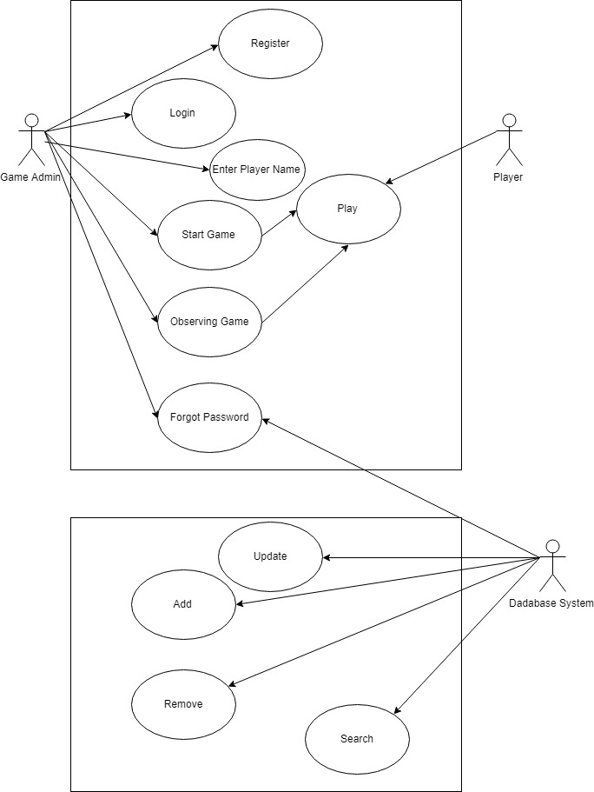

MP is responsible for storing and creating all data related to all objects. The AM functions indicate the definition of the structure and how to monitor what can be done with them. DBM is responsible for storing all sounds and objects. DBM also records the user's achievements.

**3.2.1 Register**

**3.2.1.1 Description**

Register allows the game admin to register to the application.

**3.2.1.2 Stimulus/Response Sequences**

*Stimulus*: The game admin click register button.

*Response*: Then system opens register screen.

*Stimulus*: The game admin fills name, e-mail, password, confirm password fields and clicks register button.

*Response*: If the entered name, e-mail and password are valid, the system opens the login screen.

**3.2.2 Login**

**3.2.2.1 Description**

The registered game administrators will be logged into the application from here.

**3.2.2.2 Stimulus/Response Sequences**

*Stimulus*: The game admin enters name and password.

*Response*: Then system checks for validity.

*Stimulus*: The game admin clicks login button.

*Response*: If the entered name and password are valid, the system opens the main menu.

**3.2.3 Add New Player**

**3.2.3.1 Description**

Game admin can create a new user from here, as well as user settings.

**3.2.3.2 Stimulus/Response Sequences**

*Stimulus*: The game admin clicks add new player button.

*Response*: Then system opens add new player screen.

*Stimulus*: The game admin enters player’s name and age and clicks the save button.

*Response*: If the entered name is valid, the system opens the main menu.

**3.2.4 Select Player**

**3.2.4.1 Description**

Game admin can select and view the players that are created before by the game admin.

**3.2.4.2 Stimulus/Response Sequences**

*Stimulus*: The game admin clicks the select player button.

*Response*: Then system opens the player list screen.

*Stimulus*: The game admin selects the player.

*Response*: The system opens the player screen.

**3.2.5 Start Game**

**3.2.5.1 Description**

From here game admin will start the game for the selected player.

**3.2.5.2 Stimulus/Response Sequences**

*Stimulus*: The game admin clicks the start game button.

*Response*: Then system starts the game.

**3.2.6 Play**

**3.2.6.1 Description**

The player starts playing the game.

**3.2.7 Observing Game**

**3.2.7.1 Description**

While the player is playing the game, the game admin will observe the game and the player's performance.

**3.2.8 Forgot Password**

**3.2.8.1 Description**

When the game admin forgets his/her password, “Forgot Password” will be used to obtain a new password for the game admin.

**3.2.5.2 Stimulus/Response Sequences**

*Stimulus*: The game admin clicks the forgot password button.

*Response*: Then system opens the password recovery screen.

*Stimulus*: The game admin enters e-mail into enter your e-mail field and clicks send button.

*Response*: Then system sends the game admin’s password to the game admin’s e-mail.

**3.2.9 Update**

**3.2.9.1 Description**

It updates the recordings such as voices, player information, password etc. created in the database before by the game admin.

**3.2.10 Add**

**3.2.10.1 Description**

Add function adds new account, new player information and audio files to the database.

**3.2.11 Remove**

**3.2.11.1 Description**

The remove function performs the deletion of the accounts, player information and audio files from the database.

**3.2.12 Search**

**3.2.12.1 Description**

The search function searches for data stored in the database and retrieve it.

**3.3 Design Constraints**

The environments where children with autism are accustomed should be integrated into the game. It is aimed that children should be able to adapt to the game faster and voluntarily want to play the game. It was also aimed that children should not feel uneasy when moving into a virtual environment and should feel familiar with the environment they play in.

Since the players of this game will be the autistic children, game admins must be very gentle and playful towards those children. On the other hand, players are expected to do whatever is required from them while in the gaming session.

**3.4 Performance Requirement**

After each object is found, the system must respond within 2 seconds to ensure continuity of the progressive parts or the responses of the player to the request to leave the game. When an object is found, system must create another object within 2 seconds for a new level. After the object has been found and the player's end-of-the-level success has been congratulated, a command must come from the avatar within 2 seconds for the other object. The game can be played on one device and only one player can play the game at a time.

**3.5 Software System Attributes**

**3.5.1 Reliability**

VR should not collapse or suspend as a result of system failure.

**3.5.2 Availability**

Sounds should be communicated very clearly and clearly to the user.

**3.5.3 Security**

The audio files do not have access by another user on the application. Apart from this, there is no requirement of security and confidentiality.

**3.5.4 Maintainability**

- All codes must be fully documented.

- The code must be modular to allow for future changes.

- Audio files should be stored in a separate data file instead of being embedded in the program code.

- Remarks should be stored in a separate data file instead of being embedded into the program code.

**3.5.5 Portability**

The system must be portable to every VR system. No other specific mobility requirements have been identified.

**3.5.6 Safety**

The system should alert the user to interrupt continuous play every 30 minutes to prevent eye strain.

**3.5.7 Training-related Requirements**

No special training is required for a user to start playing the game. When the game is started for the first time, you should give brief information about how to play the avatar.

**3.5.8 Packaging Requirements**

The system must be packaged with the source code and all documentation and available for electronic transmission as a compressed file for any school. To run the game, it must contain a readme.txt file that contains at least one guide inside the file.

**3.6 Comparison with Existing Games for Children with ASD**

One of the biggest problems of children with autism is that they have attention problems which cause them to have learning difficulties. A similar VR game project for the children with autism was done by the students of the computer engineering and psychology department of Yaşar University. The reactions of children to moving and stationary objects as well as reactions to different colored objects were tested with this virtual reality game. This project is very similar to our project since both project’s purpose is to help those special children to overcome their attention deficit problem in their real life. In our game, as a first stage, children will be asked to make an eye contact with an avatar in the game, after making an eye contact, children will be asked to find and focus on the objects that are going to appear throughout the game. The purpose of this process is same as the project that mentioned at the beginning of this paragraph.

**4. Game Design**

**4.1 Story of the Game**

With the voice from the avatar, user needs to find the avatar and make an eye contact and then the user is ready to play the game. It is intended that in the given time intervals for each and every object, the user needs to find the objects that are going to appear randomly in the classroom. After finding an object, it expected that the user needs to find the remaining objects that are going to appear in the classroom until the end. Upon finding the each object, there are going to be several animations which attract the user’s attention. After spending a certain time in the game, periodically, the user will be asked that whether the user wants to continue or exit the game.

**4.2 Purpose of the Game**

It is aimed that children with autism who have hard time to focus and communicate in real life, can improve their focusing and communication abilities by finding the objects and communicating with the avatar in our game which is in a virtual world.

**4.3 Game Type**

Special education and rehabilitation game

**4.4 Target Audience**

Children with autism aged 9 to 18.

**4.5 Gameplay**

In the presence of voice commands that will come from an avatar in the VR environment, the user will be asked to locate objects within a certain time period by looking at the correct direction of the objects. The user will be asked after a certain period of time whether he / she wants to continue the game (he / she will be asked to look at the classroom door for exit or to look at the board to continue the game).

**4.6 Controls**

In the game where the user plays with VR headset, it is enough to turn the user's head to left or to right to see the objects. If the object is focused by the user for a certain period of time, the system will understand that the object is located.

**4.7 Graphics**

The graphics of the game will be prepared in 3D and in cartoon style.

**4.8 User Interface**

**4.9 Pages**

Some pages in the application are in below:

Login

Main Menu

- Add New Player

- New Player Settings

- Start

- Select Player

- Start

**4.10 Game Environment**

A classroom environment will be used as a game environment which will resemble the classroom where children are educated.

**5. Design**

**5.1 Software Methodology**

In this project, AGILE methodology is being used. Agile is a software development discipline that adapts to changing conditions rather than long-term solid planning and development processes to satisfy the customer, and introduces new releases in very short intervals.

Although it pleases the user base as it allows the development steps to follow with new software versions instead of reports, the change-open structure can cause deadline shifts by changes made by both the customer and the development team, so it is necessary to think about this side while opting as part of large plans.  
  
On the other hand, agile focuses on interpersonal communication in order to minimize the distress caused by changing plans. They keep the teams small and expect them to organize themselves.

Methodologies such as Extreme programming and Scrum are under the roof of this discipline.  
Extreme programming is a software development discipline. Accordingly, everyone who contributes to the software, as a team, participates in all development stages of the code. An outside person is a part of the team representing the people who will use the product and creates situations for testing the code at every stage. The code is developed in small parts and comprehensible. Every piece is tested carefully and the design is optimized and improved. As the whole code is developed, everyone involved with the code has a complete idea about the product and completes its part completely. The result is an excellent working structure.

As described in the Scrum Guide, a Sprint, a time-box of one month or less during which a “Done”, useable, and Scrum Sprint is part of the Empirical Process. Potentially releasable product increment is created. Sprints have consistent durations throughout a development effort. A new Sprint starts immediately after the conclusion of the previous Sprint.

During the Sprint: No changes are made that would endanger the Sprint Goal, quality goals do not decrease and scope may be clarified and re-negotiated between the product owner and development team as more is learned.

Each Sprint may be considered a project with no more than a one-month horizon. Like projects, Sprints are used to accomplish something. Each Sprint has a goal of what is to be built, a design and flexible plan that will guide building it, the work, and the resultant product increment.

Sprints are limited to one calendar month. When a Sprint’s horizon is too long the definition of what is being built may change, complexity may rise, and risk may increase. Sprints enable predictability by ensuring inspection and adaptation of progress toward a Sprint Goal at least every calendar month. Sprints also limit risk to one calendar month of cost.

As for our project, we are going through sprinting. We hold meetings on certain days of the week. In the software development section, all members of the project help each other in the parts they know.

**5.2 System Architecture**

Figure 1 depicts the high-level system architecture. The system will be constructed from multiple distinct components:

• Game Admin Interface — Interface for constructing and editing Game, and viewing or exporting proﬁles.

• Game Interface — The game-like environment for executing Game and collecting data.

• VR — Connect to your android phone and play the game

• Data Model — The classes needed to organize, Tasks, Proﬁles, Points, etc.

• Data Storage — The interface for storing, importing and exporting the data model and collected data.

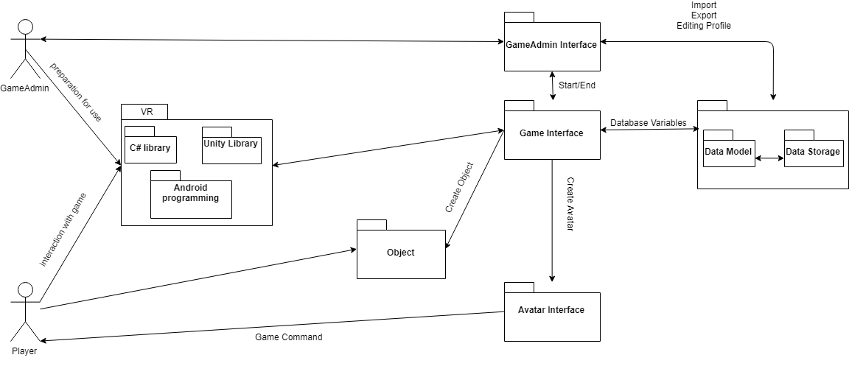

Figure 1

**5.3 Use-Case Diagrams and Activity Diagrams**

**5.3.1 Use-Case Diagrams**

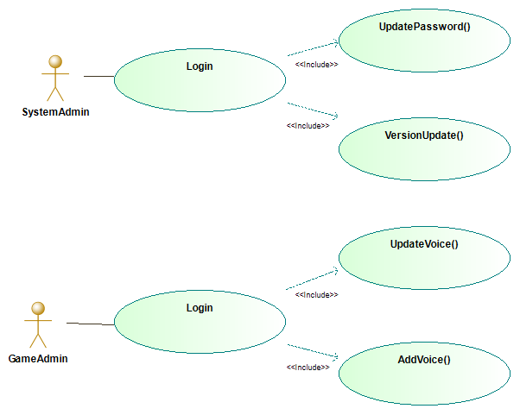

Figure 2

In Figure 2, Login process is shown and it shows the functions that are included in this process. When admin wants to login, system activates following functions;

a) GameAdmin

1) UpdateVoice()

2) AddVoice()

b) SystemAdmin

1) UpdatePassword()

2) VersionUpdate()

After these functions, system completes Login process.

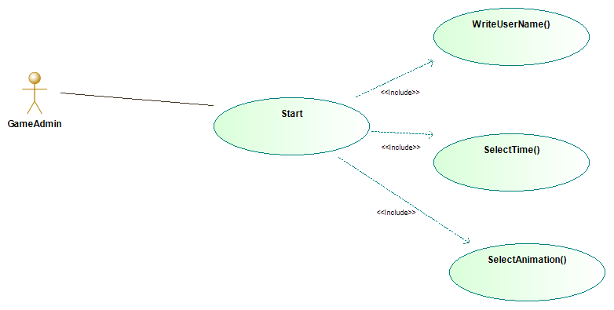

Figure 3

In Figure 3, Start process is shown and it shows the functions that are included in this process. Start function includes some system functions and these are;

1) WriteUserName()

2) SelectTime()

3) SelectAnimation()

When the start process is initiated, game admin chooses focus time, animations and voices for the player. When the start button is pressed, game admin enters player`s name and starts the game.

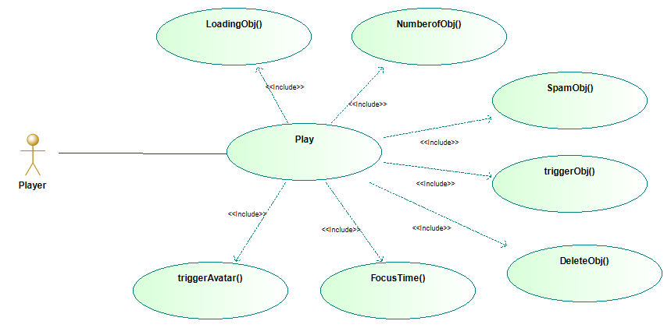

Figure 4

In Figure 4, Play process is shown and it shows the functions that are included in this process.

Play function includes some system functions and these are;

1. triggerAvatar()
2. SpawnObj()
3. triggerObj()
4. DeleteObj()
5. LoadingObj()
6. FocusTime()
7. NumberofObj()

In the play process, the player is expected to make an eye contact with the avatar in the game. After eye contact, an object will be spawned. After the object has been spawned, the player will be expected to look at the object for the specified period of time. After this process, the object disappears and another object will be spawned for the next level. During this time, the focus time and the number of objects found are calculated.

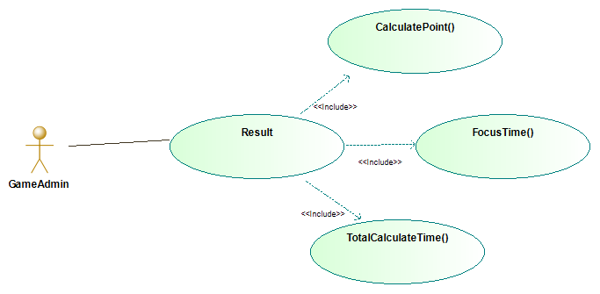

Figure 5

In Figure 5, Result process is shown and it shows the functions that are included in this process.

Result function includes some system functions and these are;

1) CalculatePoint()

2) FocusTime()

3) TotalCalculateTime()

With the result function, the focus time will be taken and a score will be calculated. At the end of the game, the scores of all players will be saved in the database.

**5.3.2 Activity Diagrams**

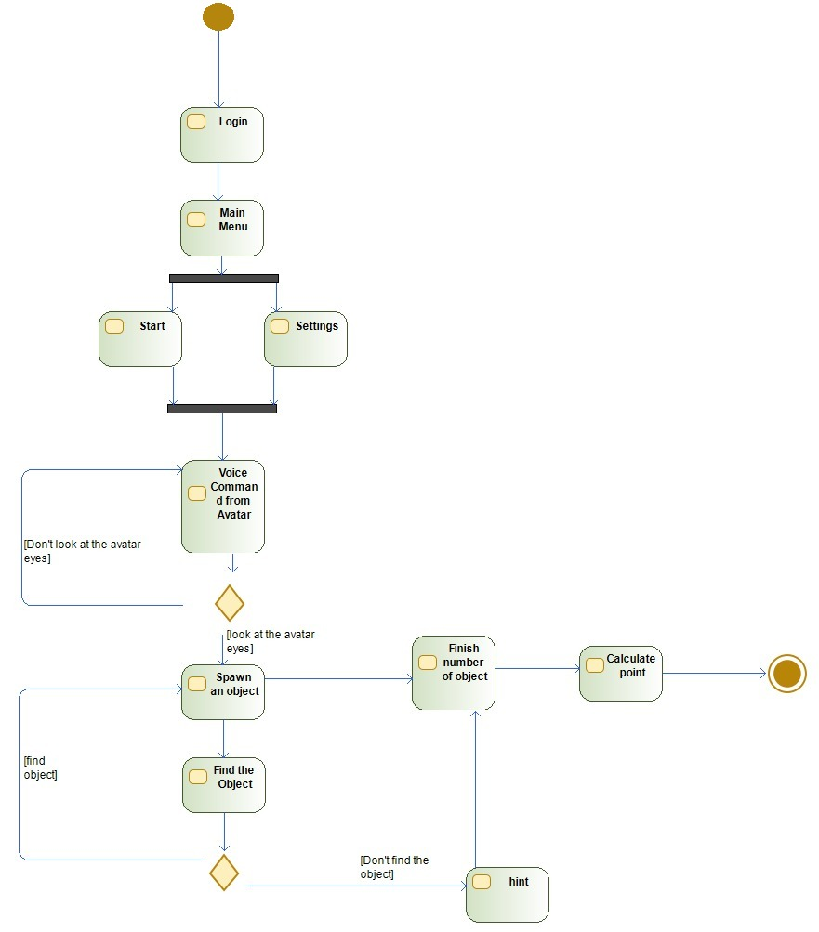**5.3.2.1 Activity Diagrams for the System**

Figure 6

Figure 6; shows the activity diagram of the system. It shows the flow of actions within the system. The player is expected to look at the avatar with the voice command from the avatar after the player starts the game. If not, the avatar is intended to attract the player's attention by speaking again. After the first interaction with the avatar, the game will spawn the first object and the player will be asked to find the object. If the player cannot find the object, the player is expected to find the object by giving them specific clues. After all the objects are found, the score is calculated and the game is expected to end.

**5.3.2.2 Activity Diagrams for GameAdmin**

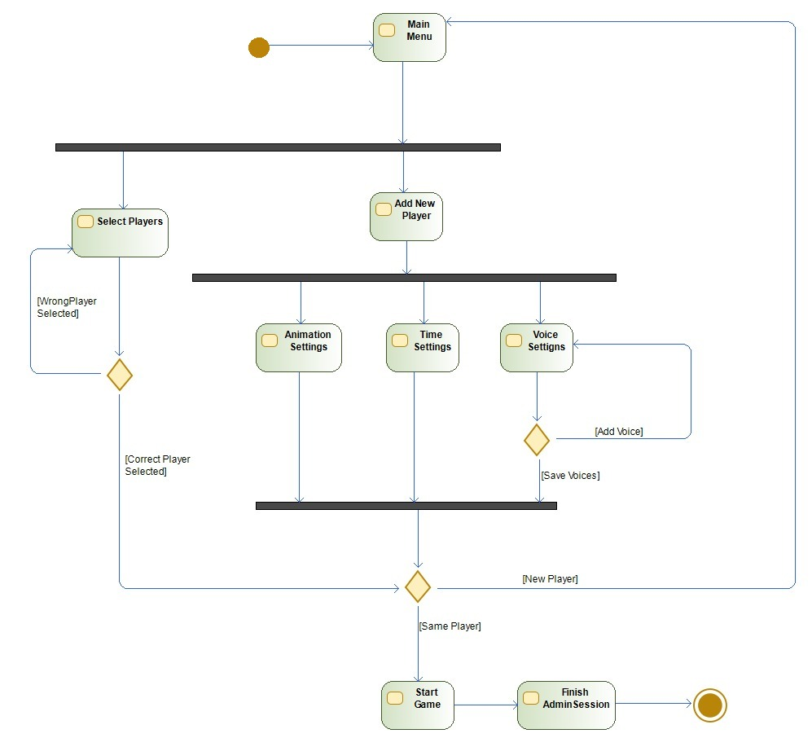

Figure 7

Figure 7; shows the GameAdmin activity diagram and the flow of GameAdmin's actions. GameAdmin first selects the player he has already registered or adds a new player. Then, GameAdmin makes the necessary adjustments to the game (Animation Settings, Time Settings, and Voice Settings). It is expected to install all the necessary audio files for the avatar. Then GameAdmin can add a new player or start the game.

**5.4 Sequence Diagram:**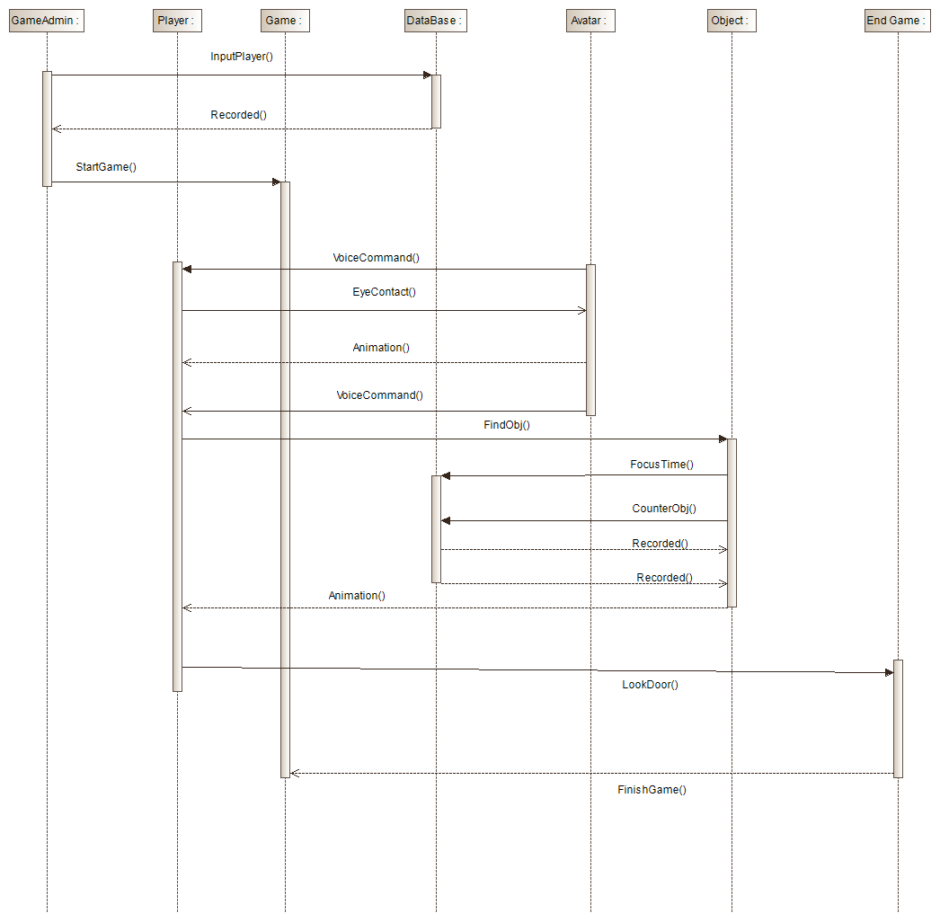

Figure 8

Figure 8; shows the system's sequence diagram. It shows the flow of successive events in the system. First, GameAdmin records the names and information of the players that will play the game in the database. Then GameAdmin starts the game and the voice command is sent to the player from the Avatar after the game starts. The player is expected to make eye contact with the avatar along with the voice command. The Avatar then asks the player to find objects with a voice command. The player is expected to find objects. The player's focus time to the object will be saved in the database. The number of objects found by the player is saved in the database with the object counter. After the player finds the object, the object returns any animation to the player. Once the player has found the specified number of objects, they are asked if they want to continue. If the player does not want to continue to look at the door and the game ends.

**5.5 Class Diagram**

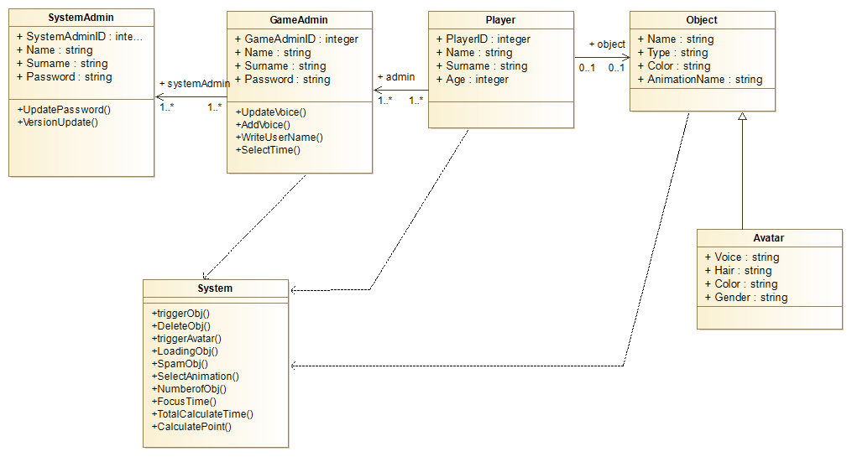

Figure 9

In Figure 9; Classes of the system are shown. There are six main classes. Their functions and attributes are defined as well their relations. System class has no attributes unlike the other classes.

**5.6 Deployment Diagram:**

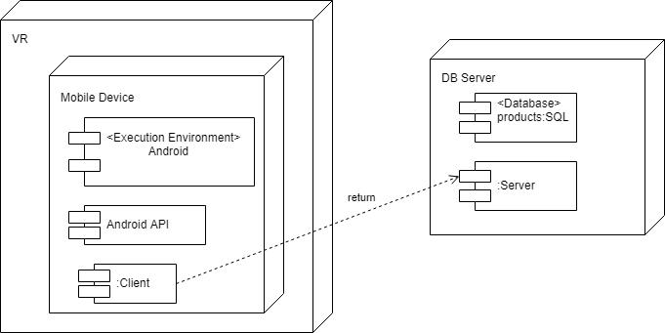

Figure 10

In Figure 10; there are 2 main sections. One section VR environment which will be played in the game environment, the other is the database data to keep the data of the game. Mobile device will be used to play the game in VR environment. Mobile device should support Android API for synchronization. At the same time, the mobile device will act as a Client for our game and will forward the database to the information saved during the game. We will create the database with SQL commands to ensure that the required information is requested and saved.

**5.7 User Interface Designs:**

In this section, user interface designs will be shown.

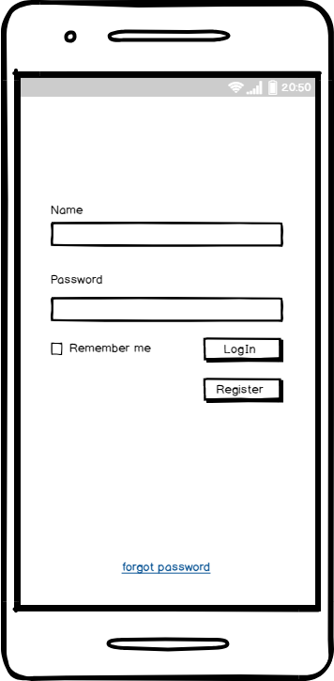

Figure 11

Figure 11; it shows what the GameAdmin or SystemAdmin sees when entering the user interface of the system. This is the screen which GameAdmin or SystemAdmin can log into the system. GameAdmin or SystemAdmin can log in when they enter their name and password. If GameAdmin or SystemAdmin is not a member, they can click the Register button on this screen.

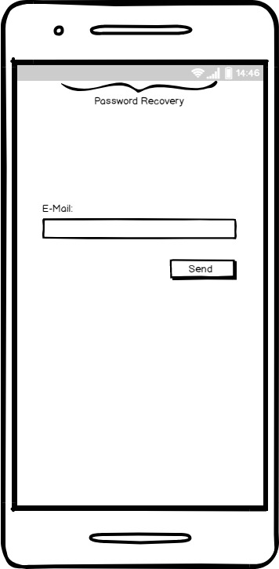

Figure 12

Figure 12; this is the Password Recovery screen. When GameAdmin forgets his password, he/she will enter his/her e-mail here.

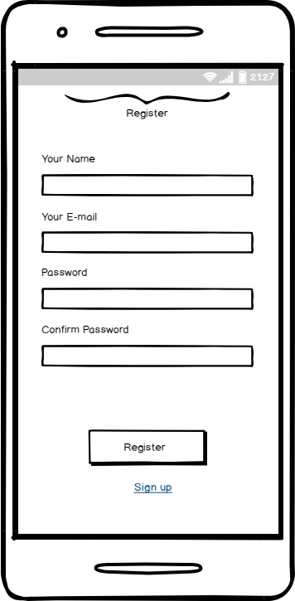

Figure 13

Figure 13, this is the Register Screen. GameAdmin will use this page if it is not a member of the system.

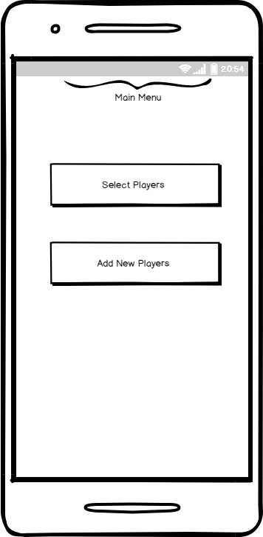

Figure 14

Figure 14, this is the Main MenuGame Admin will be able to select the players it has entered before or create a new player.

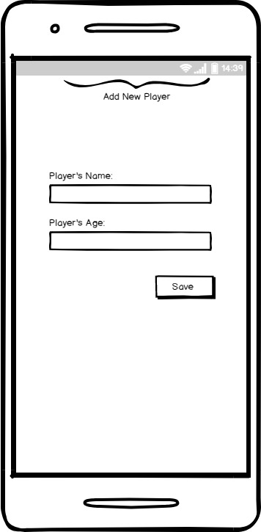

Figure 14

Figure 15

Figure 15; this is the Add New Players screen. Game Admin will be able to add the user's name, surname and age.

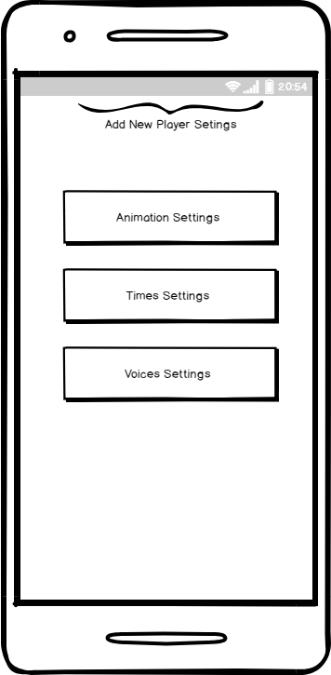

Figure 16

Figure 16; this is the Add New Players Settings screen. Game Admin is able to set the settings for the new user.

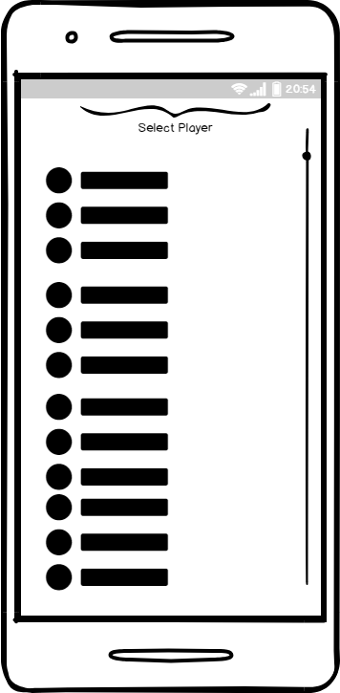

Figure 17

Figure 17; this is the Select Player screen. Game Admin can select and view the player that he/she has entered before.

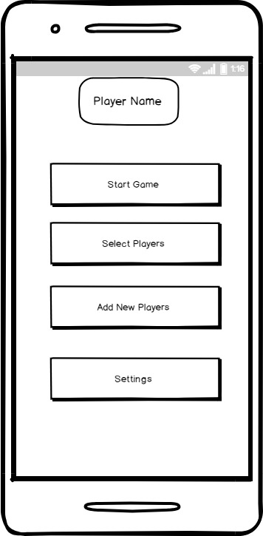

Figure 18

Figure 18; This is the Player Name screen. GameAdmin will start the game for the player selected here.

**6. Appendices**

We had done an interview with Dr. Mehtap Tufan. Topics covered in this interview:

- Active students should be selected from the class,

- The commands in the game must be clear and implicit,

- Hints should be given to the players for the objects that are hard to find,

- Using female avatar may become an advantage for male students,

- Colorful environments that may cause distractions should be avoided,

- No other objects appear in the same environment except for the object to be found,

- Congratulations should be given to the player in case of finding the right object,

- Game environment should as quiet as possible.